MObility managment

Mobility Management Overview
Objectives
This lesson describes the major aspects of Mobility management of the GSM system. After completion of this lesson the student is able to:
- Describe how the MS network attachment process is performed
- Explain the concept of a PLMN area and its location areas
- Explain the relationship between the PLMN area and the MSC-VLR areas
- Describe the functions of the HLR and the VLR in relation to Mobile management
- Describe how the Location Update process is performed
- Explain the need for mobile authentication and describe the process.
Lesson topics This lesson discusses the following topics:
- Network attachment
- Locating a mobile station
- Location registration
- Mobile station identification
- Location update process
- Request for service phase
- Authentication and ciphering phases
- Update HLR/VLR and TMSI re-allocation phases
- Periodic location update.

Network attachment
Definition
Network attachment is the process of selecting an appropriate cell (radio frequency) by the mobile station to provide the available services, and making its location known to the network.
The process starts when the mobile station is switched on, and ends when the mobile station enters the idle mode. In idle mode the mobile station does not have a traffic channel allocated to make or receive a call. But the Public Land Mobile Network (PLMN) is aware of the existence of the Mobile station within the chosen cell.

Network ATTACHMENT PROCESS
The network attachment process consists of the following tasks:
Cell identification
When a mobile station is switched on it attempts to make
Contact with a GSM PLMN by performing the following actions:
- Measure the BCCH channels
- Search for a suitable cell
The mobile station measures the signal strength of the BCCH (Broadcast Control Channel) channels received. It stores in list information about 30 of these BCCH channels, such as the signal strength and the frequency corresponding to these BCCH channels.
PLMN selection
A suitable PLMN is chosen
Cell Selection
Cell selection is the process of selecting an appropriate cell (radio frequency) by the mobile station to provide the available services.
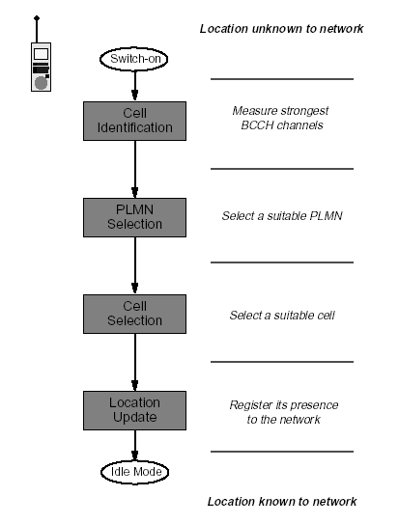
The following figure shows the network attachment process.

Location update
In order to initiate a call or to receive a call, the mobile station tunes to the control channel (BCCH plus CCCH) of the chosen cell. Then, it registers its presence in this cell (registration process) by means of a location updating procedure.

No suitable cell found
If the mobile station is unable to find a suitable cell to access, it attempts to access a cell irrespective of the PLMN identity, and enters a “limited service” state in which it can only attempt to make emergency calls.

PLMN selection mechanism
The parts PLMN to be contacted can be selected either in one or the following modes:
- Automatic mode
In automatic mode, the mobile station will choose which PLMNs to try all by itself. The automatic mode is based on the existence of the preferred list, which is stored in a non-volatile memory in the SIM. This list includes a number of PLMN identities in order of preference and is under control of the user. The most preferred is usually the home PLMN. The list is filled in by the user through a mechanism to be specified by the mobile station manufacturer.
The automatic mode is normally used when the mobile station operates on its home PLMN that is the PLMN the mobile station is subscribed to).
- Manual mode
In manual mode, the user is presented a list containing all found PLMNs. The user chooses one of the PLMNs from the list.

Cell selection criteria
The mobile station attempts to find a suitable cell by passing through the list in descending order of received signal strength; the first BCCH channel which satisfies a set of requirements is selected.
The requirements that a cell must satisfy (before a mobile station can provide service from it) are:
- It should be a cell of the selected PLMN. The mobile station checks whether the cell is part of the selected PLMN. It should not be “barred”.
- The PLMN operator may decide not to allow mobile stations to access certain cells. These cells may, for example, only be used for handover traffic. Barred cell information is broadcast on the BCCH to instruct mobile stations not to access these cells.
- The radio path loss between the mobile station and the selected BTS must be below a threshold set by the PLMN operator.

Locating a mobile station
Call to an active mobile station
As an active Mobile Station (MS) moves around in the coverage area of a Public Land Mobile Network (PLMN), it reports its movements so that it can be located when required using the Location Update procedure.
When a Mobile-services Switching Center (MSC) in the network needs to establish a call to an MS operating in its area the following happens:
A page message is broadcast which contains the identifications code of the MS.
Not every Base Station Controller (BSC) in the network is requested to transmit the page message. The broadcast is limited to a cluster of radio cells that together form a location area. The last reported position of the MS identifies the location area to be used for the broadcast.
The MS monitors the page messages transmitted by the radio cell in which it is located and, on detecting its own identification code, responds by transmitting a page response message to the Base Transceiver Station (BTS).
Communication is then established between the MSC and the MS via the BTS that received the page response message.

Network configuration

The configuration of a Public Land Mobile Network (PLMN)
is designed so that an active mobile station moving in the network’s area is always able to report its position.
A network consists of different areas:
- PLMN area
- Location area
- MSC area
- VLR area.

PLMN area
A Public-Land-Mobile-network (PLMN) area is the geographical area in which a particular PLMN operator provides land mobile communication services to the public. From any position within a PLMN area, the mobile user can set up calls to another user of the same network, or to a user of another network. The other network may be a fixed network, another GSM PLMN, or another type of PLMN. Other network users, and users of other networks, can also call a mobile user who is active in the PLMN area.
When there are several PLMN operators, the geographical areas covered by their networks may overlap. National borders normally limit the extent of a PLMN area.

Location areas
To eliminate the need for network-wide paging broadcasts, the PLMN within its coverage area. To enable the approximate position of any MS to be represented by a single parameter, the total area covered by the network is divided into location areas.
A location area (LA) is a cluster of one or more radio cell. The cell cluster fulfils the following requirement:
- The BTSs in a location area are controlled by one or more BSCs.
- BSCs that serve the same location area are always connected-to the same MSC.
- Radio cells with BTSs controlled by a common BSC can lie in different location areas
The following figure shows the location and MSC areas
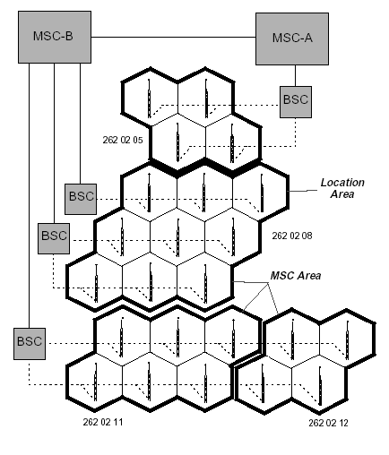

Location area identity
Every radio transmitter in the PLMN broadcasts, via a control channel, a Location Area Identity (LAI) code to identify the location area that it serves.
When an MS is not engaged in a call, it automatically scans the control channel broadcasts transmitted by the base stations in the locality and selects the channel that is delivering the strongest signal. The LAI code broadcast by the selected channel identifies the location area in which the MS is currently situated. This LAI code is stored in the Subscriber Identity Module (SIM) of the mobile equipment.
As the MS moves through the network area the signal received from the selected control channel gradually diminishes in strength until it is no longer the strongest. At this point the MS re-tunes to the channel that has become dominant and examines the LAI code that it is broadcasting. If the received LAI code differs from that stored on the SIM, then the MS has entered another location area and initiates a location update procedure to report the change to the MSC. At the end of the procedure the LAI code in the SIM is also updated.

Location area identity format
A Location Area Identity (LAI) code identifies the location area in a PLMN. The LAI code has three components:
Mobile Country Code (MCC)
The MCC is a 3-digit code that uniquely identifies the country of domicile of the mobile subscriber (for example, Germany is 262, India is 404 and Brunei is 528 etc). It is assigned by the ITU-T
Mobile Network Code (MNC)
The MNC is a 2-digit code (3-digit code for GSM-1900) that identifies the home GSM PLMN of the mobile subscriber. If more than one GSM PLMN exists in a country, a unique MNC s assigned to each of them. It is assigned by the government (DOT) of each country.
Location Area Code (LAC)
The LAC component identifies a location area within a PLMN; it has a fixed length of 2 octets and can be coded using hexadecimal representation. It is assigned by an operator.

Figure the following figure shows a representation of LAI
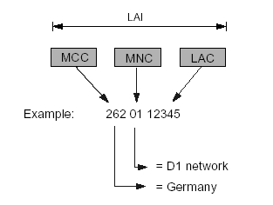

MSC areas
An MSC area is a region of the network in which GSM operations are controlled by a single MSC. An MSC area consists of one or more location areas. The boundary of an MSC area follows the external boundaries of the location areas on its periphery. Consequently, a location area never spans the boundary of an MSC area.

VLR areas
A VLR area is a region of the network that is supervised by a single Visitor Location Register (VLR). In theory, a VLR area may consists of one or more MSC areas. In practice, however, the functions of the VLR are always integrated with those of the MSC so that the terms “VLR area” and “MSC area” have become synonymous.

Location registration

Location related data bases
Two data bases are used by Location Management to store MS location related data. Visitor Location Register (VLR) and Home Location Register (HLR).

Visitor Location Register
A VLR contains a data record for each of the MS that are currently operating in its area. Each record contains a set of subscriber identity codes, related subscription information, and a Location Area Identity (LAI) code. This information is used by the MSC when handling calls to or from an MS in the area.
When an MS moves from one area to another, the responsibility for its supervision passes from one VLR to another. A new data record is created by the VLR that has adopted the MS, and the old record is deleted.
Provided that an interworking agreement exists between the network operators concerned, data transactions can cross both network and national boundaries.

Home Location Register
The HLR contains information relevant to mobile subscribers who are fee-paying customers of the organization that operates the PLMN.
The HLR stores two types of information:
Subscription information
The subscription information includes the identity code and directory number allocated to the subscriber, the type of service(s) provided, and any related restrictions.
Location Information
The location information includes the address of the VLR in the area where the subscriber’s MS is currently located, and the address of the associated MSC.
The location information enables incoming calls to be routed to the MS. The absence this information indicates that the MS is inactive and cannot be reached.
When an MS moves from one VLR area to another, the location information in the HLR is updated with the new VLR and MSC addresses. The VLR then creates a new entry for the MS, using subscription data copied from the HLR.
Provided that an interworking agreement exists between the network operators concerned, data transactions can cross both network and national boundaries.

Mobile station identification

Types of identification numbers
During the performance of the location update procedure and the processing of a mobile call different types of numbers are used:
- Mobile Station ISDN Number (MSISDN)
- Mobile Subscriber Roaming Number (MSRN)
- International Mobile Subscriber Identity (IMSI)
- Temporary Mobile Subscriber Identity (TMSI)
- Local Mobile Station Identity (LMSI)
- Each number is stored in the HLR and/or VLR.

Mobile Station ISDN Number
The MSISDN is the directory number allocated to the mobile subscriber. It is dialed to make a telephone call to the mobile subscriber. The number consists of Country Code (CC) of the country in which the mobile station is registered (for example, Germany is 49, and Brunei is 63), followed by national mobile number which consists of Network Destination Code (NDC) and Subscriber Number (SN). A Network Destination Code is allocated to each GSM PLMN. The maximum number of digits of the Digit Subscriber Number is a standard of 12 in accordance with ITU Recommendation. Previously the maximum number of digits allowed was limited to 10.
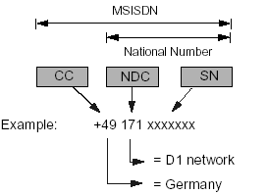
The following figure shows a representation of MSISDN

The composition of the MSISDN is such that it can be used as a global title address in the Signaling Connection Control Part (SCCP) for routing messages to the HLR of the mobile subscriber.

Mobile Station Roaming Number
The MSRN is the number required by the gateway MSC to route an incoming call to a MS that is not currently under the gateway’s control.Using the MSISDN a mobile-terminated call is routed to the gateway MSC. Based on this, MSISDN the gateway MSC requests for a MSRN to route the call to the current visited MSC.

International Mobile Subscriber identity
A MS is identified by its IMSI. The IMSI is embodied in the SIM of the mobile equipment. The MS provides it anytime it accesses the network.An IMSI code has three components:
- Mobile Country Code (MCC)
The MCC component of the IMSI is a 3-digit code that uniquely identifies the country of the domicile of the subscriber. It is assigned by the ITU-T.
- Mobile Network Code (MNC)
The MNC component is a 2-digit code that identifies the home GSM PLMN of the mobile subscriber. The government of each country assigns it. For GSM-1900 a 3-digit MNC is used.
- Mobile Subscriber Identification Number (MSIN)
The MSIN is a code that identifies the mobile subscriber within a GSM PLMN. An operator assigns it.
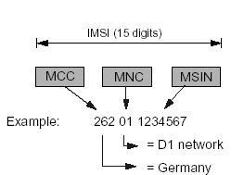
The following figure gives a representation of IMSI.

The overall number of digits in an IMSI code does not exceed 15.

Temporary Mobile Subscriber Identity
The TMSI is an identity alias that is used instead of the IMSI when possible. The use of the TMSI ensures that the true identity of the `Mobile subscriber remains confidential by eliminating the need to transfer an IMSI code enciphered over a radio link. A VLR allocates a unique TMSI code to each mobile subscriber that is operating in its area. This code, which is only valid within the area supervised by the VLR, is used to identify the subscriber in messages to and form the MS. When a change of location area also involves a change of VLR area. A new TMSI code is allocated and communicated to the MS. The MS stores the TMSI on its SIM. The TMSI consists of four octets; coded using a full hexadecimal representation.

Local Mobile Station Identity
The LMSI is temporary subscriber data. Note that the use of the LMSI is optional. In order to speed up the search for subscriber data in the VLR a supplementary Local Mobile Station Identity (LMSI) can be defined. The LMSI is allocated by the VLR. Location updating and is sent to the HLR together with the IMSI. The HLR makes no use of it but includes it together with the IMSI in all messages sent to the VLR concerning that MS.

Location update process

Phases of a location update
The following table lists the location update process:
Stage Description
1. Request for service; the MS detects that it has entered a new Location Area and requests to update its location. The new MSC/VLR identifies the MS.
- Authentication; the new MSC/VLR requests to the AUC for authentication parameters. Using these parameters the MS is authenticated.
- Ciphering; using the parameters that were made available earlier during the authentication the uplink and the downlink are ciphered.
- Update HLR/VLR; the new MSC/VLR requests to update the MS location in the HLR. The MS is de-registered in the old VLR.
- TMSI re-allocation; the MS is assigned a new TMSI.

Optional phases
The authentication and ciphering phases are optional: they might not take place in a Location Update, depending on the service supplier’s decision.

Call scenarios
The Location Update process and its different phases area explained in more detail using call scenarios shown in the following figures:
Phases of a location update (1)
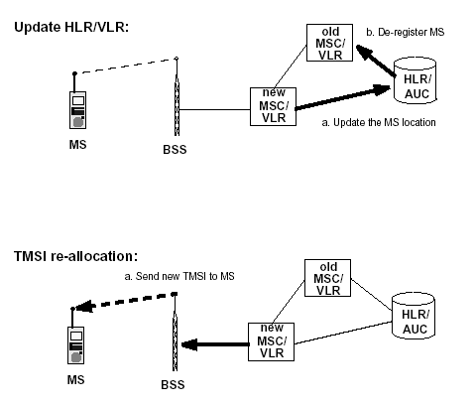

Request for Service Phase

Steps in request for service phase
In the following location update scenario, it is assumed that a MS enters a new location area that is under control of a different VLR (referred to as the “new VLR”) than the one where the MS is currently registered (referred to as the “old VLR”).
The following figure shows the steps of the mobile location update scenario.
The MS enters a new cell area, listens to the Location Area Identity (LAI) being transmitted on the broadcast channel (BCCH), and compares this LAI with the last LAI (stored in the SIM) representing the last area where the mobile was registered.
- The MS detects that it has entered a new Location Area and transmits a Channel Request message over the Random Access Channel (RACH).
- Once the BSS receives the Channel Request message, it allocates a Stand-alone Dedicated Control Channel (SDCCH) and forwards this channel assignment information to the MS over the Access Grant Channel (AGCH). It is over the SDCCH that the MS will communicate with the BSS and MSC.
- The MS transmits a location update request message to the BSS over the SDCCH. Included in this message are the MS Temporary Mobile Subscriber Identity (TMSI) and the old Location Area Identification (oldLAI). The MS can identify itself either with its IMSI or TMSI. In this example we’ll assume that the mobile provided a TMSI. The BSS forwards the location update request message to the MSC.
- The VLR analyzes the LAI supplied in the message and determines that the TMSI received is associated with a different VLR (oldVLR). In order to proceed with the registration, the IMSI of the MS must be determined. The new VLR derives the identity of the oldVLR by using the received LAI, supplied in the location update request message. It also requests the old VLR to supply the IMSI for a particular TMSI.

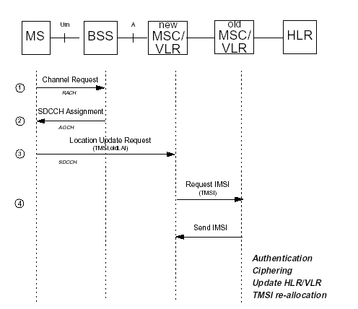

Authentication and ciphering phases
Authentication
Since the air interface is vulnerable to fraudulent access, it is necessary to determine if the IMSI received from the MS is from the SIM that was assigned this IMSI. To prevent access of unregistered users authentication of subscribers is used. Authentication is built around the notion and Authentication Key (Ki) that resides in only two places: in an Authentication Center (AUC) and in the user’s SIM card. Since the authentication key, Ki, is (or should) never be transmitted, in is virtually impossible for un-authorized individuals to obtain this key to impersonate a give mobile subscriber.

Authentication paramters
The MS is authenticated by the VLR with a process that uses three parameters.
RAND, which is completely random number
SRES, which is an authentication signed response. I is generated by apply in an authentication algorithm (A3) to RAND and Ki.
Kc, which is a cipher key. The Kc parameter is generated by applying the cipher key generation algorithm (A8) to RAND and Ki.
These parameters (named an authentication triplet) are generated the AUC at the request of the HLR to which the subscriber belongs. The algorithms A3 and A8 are defined by the PLMN operator and are executed by the SIM..
The following figure shows the scheme of the algorithms.
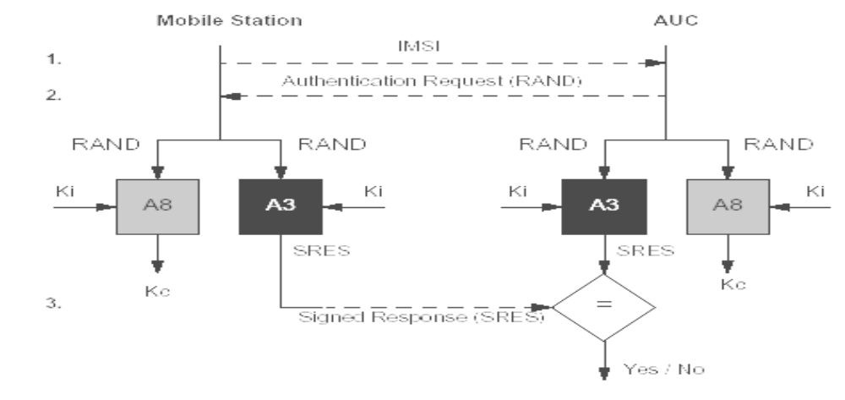

Authentication process
To authenticate a subscriber, the VLR sends an authentication request message to the MS (step 2, in the figure). The message contains the RAND parameter from an authentication triplet. The MS applies the A3 algorithm to the received RAND and the Ki key taken from the SIM. The resulting SRES is returned to the VLR for verification (step 3). The VLR authenticates the subscriber if the SRES value returned by the MS is equal to that in the triplet involved.
As well as calculating the value of SRES, the MS applies the A 8 algorithm to the received RAND and the Ki key from the SIM. The Result is the value of Kc to be used when the radio link has been switched to ciphered mode.

Steps in authentication phase
The step in the authentication phase is as follows:
- The new VLR sends a request to the HLR/AUC (Authentication and Kc) requesting the “authentication triplets” (RAND, SRES, and Kc) available for the specified IMSI.
- The AUC, using the IMSI, extracts the subscriber’s authentication key (Ki). The AUC then generates a random number (RAND), applies the Ki and RAND to both the authentication algorithm (A3) and the cipher key generation algorithm (A8) to produce an authentication Signed Response (SRES) and a Cipher Key (Kc). The AUC then returns to the new VLR an authentication triplet: RAND, SRES, and Kc.
- The MSC/VLR keeps the two parameters Kc and SRES for later use and then sends a message to the MS. The MS reads its Authentication key (Ki) from the SIM, applies the received random number (RAND) and Ki to both its Authentication Algorithm (A3) and Cipher key generation Algorithm (A8) to produce an authentication Signed Response (SRES) and Cipher Key (Kc). The MS saves Kc for later, and will use Kc when it receives command to cipher the channel.
- The MS returns the generated SRES to the MSC/VLR. The VLR compares the SRES returned from the MS with the expected SRES received earlier from the AUC. If equal, the mobile passes authentication. If unequal, all signaling activities will be aborted. In this scenario, we’ll assume that authentication passes.
The figure the following figure shows the step in the authentication phase.

MS
BSS
New
MSC/
VLR
Old
MSC/
VLR
HLR
Get authentication parameters
(IMSI)
Authentication parameters
(SRES, Kc, RAND)
Authentication Mobile station
(RAND)
Authentication response
(SRES)
Request for service
SDCCH
(1)
(2)
(3)
(4)
SDCCH

Steps in ciphering phase
The steps in the ciphering phase are as follows:
- The new MSC/VLR requests the BSS to cipher the radio channel. Included in this message is the Cipher Key (Kc), which was made available earlier during the authentication.
- The BSS retrieves the cipher key, Kc, from the message and then transmits a request to the MS requesting it to begin ciphering the uplink channel.
- The MS uses the cipher key generated previously when it was confirmation over the ciphered channel to the BSS
- The BSS upon ciphering the downlink channel sends a cipher complete message to the MSC.

The following figure shows the steps in the ciphering phase.

MS
BSS
New
MSC/
VLR
Old
MSC/
VLR
HLR
Cipher - uplink - channel
SDCCH
(1)
(2)
(3)
(4)
SDCCH
Uplink - channel-Ciphered
Uplink -radio channel
(Kc)
Ciphering completed
BSS Cipher the downlink channel
Update HLR/VLR
TMSI re-allocation
Um
A

Update HLR/VLR and TMSI re-allocation phases

Steps in update HLR/VLR phase
At this point, we are ready to inform the HLR that the MS is under control of a new VLR and that the MS can be de-registered from the old VLR.
The steps in the update HLR/VLR phase are:
1. The new VLR sends a message to the HLR informing it that the given IMSI has changed locations an can be reached by routing all incoming calls to the VLR address included in the message
2. The HLR requests the old VLR to remove the subscriber record associated with the given IMSI. The request is acknowledge.
3. The HLR updates the new VLR with subscriber data (mobiles subscriber’s customer profile).
The following figure shows the steps in the update location phase.

MS
BSS
New
MSC/
VLR
Old
MSC/
VLR
HLR
(1)
(2)
(3)
Authentication
Ciphering
De-register
Mobile Station
Update location
Um
A
Mobile Station
De-registered
Location Updated

Steps in TMSI re-allocation phase
At this point in time, the HLR and “oldVLR” have been informed that the MS has registered with an MSC under the control of the “new VLR”/
The remaining task for the new VLR is to allocate and transmit a new TMSI to the MS. For security reasons, the radio channel is encrypted before sending the new TMSI to the MS.

The steps in the TMSI re-allocation phase are:
- The MSC forwards the location update accept message to the MS. This message includes the new TMSI.
- The MS retrieves the new TMSI value from the message and updates its SIM with this new value. The mobile sends then an update complete message back to the MSC.
- The MSC requests from the BSS that the signaling connection be released between the MSC and the MS.
- The MSC releases its portion of the signaling connection when it receives the clear complete message from the BSS.
- The BSS sends a “radio resource” channel release message to the MS and then frees up the Stand-alone Dedicated Control Channel (SDCCH) that was allocated previously. The BSS then informs the MSC that the signaling connections have been cleared.

The following figure shows the steps of the TMSI Re-allocation phase.

MS
BSS
New
MSC/
VLR
Old
MSC/
VLR
HLR
SDCCH
(1)
(2)
(3)
(4)
SDCCH
Release radio
Signaling
Channel
Location Update
Complete
Um
A
Location Update
Accept (TMSI)
Clear Signaling connection
Clear
Complete
SDCCH

Periodic location update
Definition
At the discretion of the network operator, every MS may be required to initiate a location update procedure at regular intervals, regardless of its movements. The length of the interval is broadcast via the control channel; it may vary from 6 minutes to 25.5 hours. The timing function is performed by the MS itself.
The periodic location update supplements the normal procedure; its purpose is to refresh location information that may have been lost or become unreliable.

